Participant Profile: Clinical Trial Detail (Fictional Example)

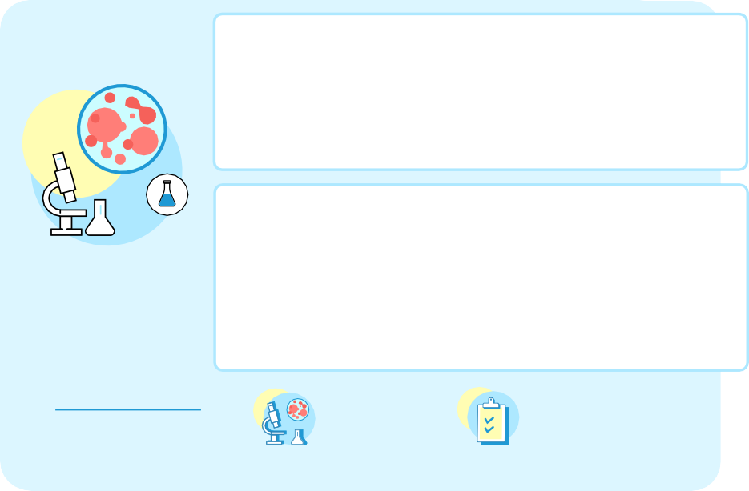

Patient Name:
Patient background
Key Considerations from interviews with patient:
Age: Sex:
Residential Location:
Occupation:
Notes:
Study Title:
ePRO:
Comorbidity:
Inclusion:
Exclusion:
Duration:

Number of Sites/Countries:
US only, 1 site in St. Louis,

Number of Participants:

Number of visits:
In person:
Virtual/Home Health Care:
Interventions:
Questionnaires:

Journey Stage

Key considerations

Key Participants

Pre-trial / Prescreening

Enrollment/Consent

Study Participation - Schedule of Activities

Study Closeout - Schedule of Activities

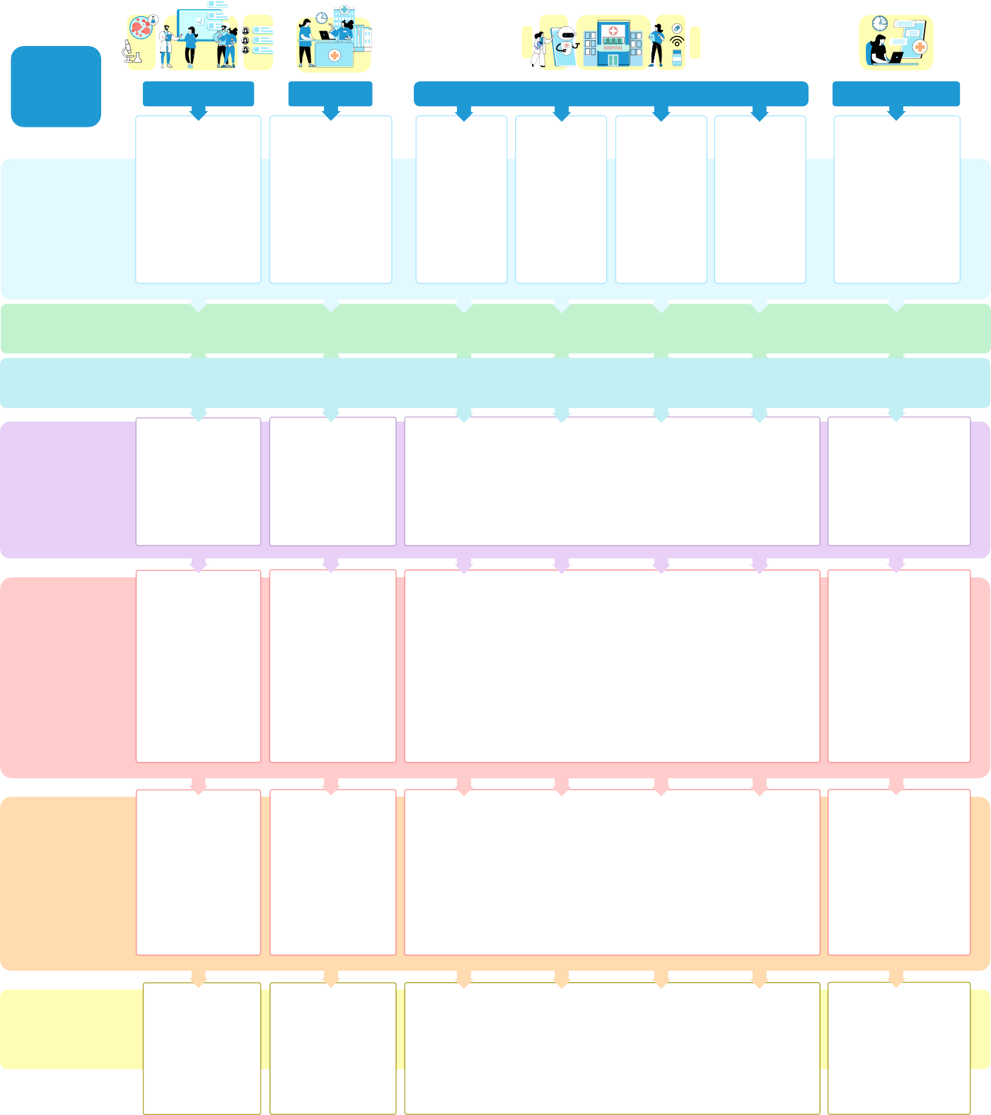
Telehealth visit
Smart pill bottle
Home health nurse visit
Diary
Study-related technology portal
Additional diary on medication ingestion

Healthcare Team

Empathy Mapping:
Thinking/feeling/doing

Pain Points
Barriers retention and engagement blockers

DCT Components

What do sponsors, sites, and tech providers
need to run a trial like this?

